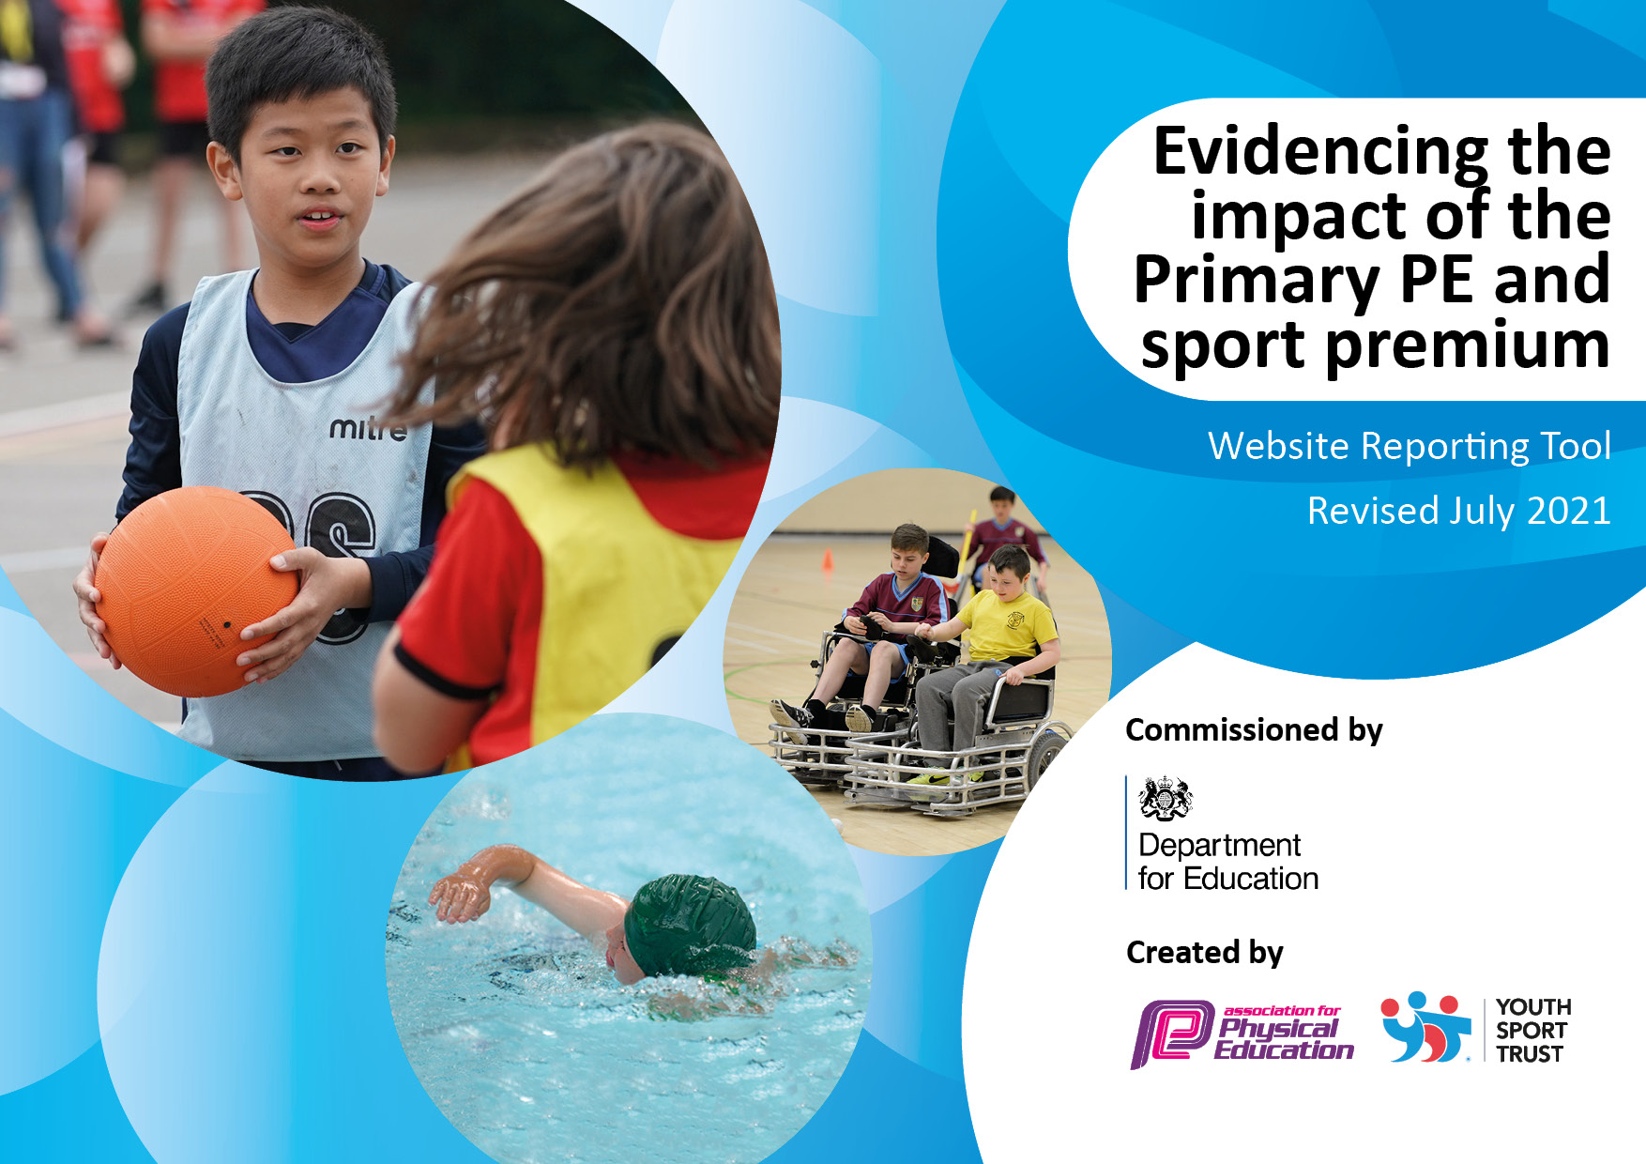
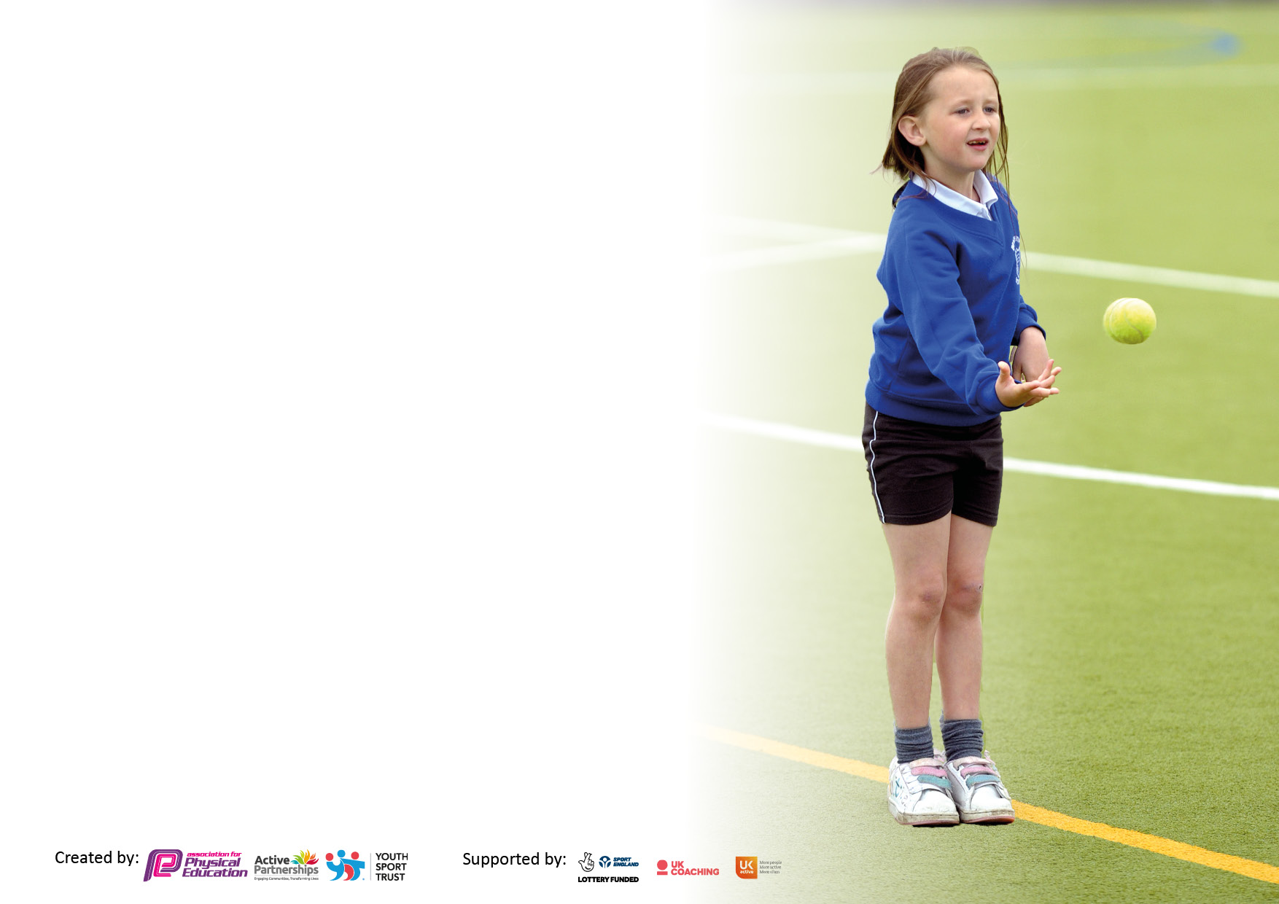

It is important that your grant is used effectively and based on school need. The Education Inspection Framework makes clear there will be a focus on ‘whether leaders and those responsible for governors all understand their respective roles and perform these in a way that enhances the effectiveness of the school’.

Under the Quality of Education Ofsted inspectors consider:
Intent - Curriculum design, coverage and appropriateness
Implementation - Curriculum delivery, Teaching (pedagogy) and Assessment
Impact - Attainment and progress

To assist schools with common transferable language this template has been developed to utilise the same three headings which should make your plans easily transferable between working documents.

Schools must use the funding to make additional and sustainable improvements to the quality of Physical Education, School Sport and Physical Activity (PESSPA) they offer. This means that you should use the Primary PE and sport premium to:

- Develop or add to the PESSPA activities that your school already offer
- Build capacity and capability within the school to ensure that improvements made now will benefit pupils joining the school in future years
- The Primary PE and sport premium should not be used to fund capital spend projects; the school’s budget should fund these.

Pleasevisitgov.ukfortherevisedDfEguidanceincludingthe5keyindicatorsacrosswhichschoolsshoulddemonstrate animprovement.Thisdocumentwillhelpyoutoreviewyourprovisionandtoreportyourspend.DfEencouragesschools to use this template as an effective way of meeting the reporting requirements of the Primary PE and sport premium.

We recommend you start by reflecting on the impact of current provision and reviewing the previous spend.

Schools are required to publish details of how they spend this funding, including any under-spend from 2019/2020, as well as on the impact it has on pupils’ PE and sport participation and attainment. All funding must be spent by 31st July 2022.

We recommend regularly updating the table and publishing it on your website throughout the year. This evidences your ongoing self-evaluation of how you are using the funding to secure maximum, sustainable impact. Final copy must be posted on your website by the end of the academic year and no later than the 31st July 2021. To see an example of how to complete the table please click HERE.

Details with regard to funding
Please complete the table below.

Total amount carried over from 2019/20 | None
Total amount allocated for 2020/21 | £17,981
How much (if any) do you intend to carry over from this total fund into 2021/22? | None
Total amount allocated for 2021/22 | £18,062
Total amount of funding for 2021/22. To be spent and reported on by 31st July 2022. | £18,062
Swimming Data
Please report on your Swimming Data below.

Meeting national curriculum requirements for swimming and water safety.

N.B. Complete this section to your best ability. For example you might have practised safe self-rescue techniques on dry land which you can then transfer to the pool when school swimming restarts.
Due to exceptional circumstances priority should be given to ensuring that pupils can perform safe self rescue even if they do not fully meet the first two requirements of the NC programme of study
What percentage of your current Year 6 cohort swim competently, confidently and proficiently over a distance of at least 25 metres?  N.B. Even though your pupils may swim in another year please report on their attainment on leaving primary school at the end of the summer term 2020.  Please see note above | 18.75%
What percentage of your current Year 6 cohort use a range of strokes effectively [for example, front crawl, backstroke and breaststroke]?  Please see note above | 18.75%
What percentage of your current Year 6 cohort perform safe self-rescue in different water-based situations? | 18.75%
Schools can choose to use the Primary PE and sport premium to provide additional provision for swimming but this must be for activity over and above the national curriculum requirements. Have you used it in this way? | No. Covid was an issue with pool closures and fewer lessons.

Action Plan and Budget Tracking
Capture your intended annual spend against the 5 key indicators. Clarify the success criteria and evidence of impact that you intend to measure to evaluate for pupils today and for the future.

Academic Year: 2021/ 2022 | Total fund allocated:£18,062 | Date Updated: 25.01.2022
Key indicator 1: The engagement of all pupils in regular physical activity – Chief Medical Officers guidelines recommend that primary school pupils undertake at least 30 minutes of physical activity a day in school |  |  |  | Percentage of total allocation:
 |  |  |  | 11%
Intent | Implementation |  | Impact
Your school focus should be clear what you want the pupils to know and be able to do and about  what they need to learn and to  consolidate through practice: | Make sure your actions to achieve are linked to your intentions: | Funding allocated: | Evidence of impact: what do pupils now know and what can they now do? What has changed?: | Sustainability and suggested next steps:
All pupils are provided with a wide range of opportunities to be physically active and they will understand how physical activity can help them to adopt a healthy and active lifestyle  All pupils are encouraged to make healthy lifestyle choices.  Most pupils engage in at least 60 minutes of physical activity a day, of which 30 minutes should be in school  There is a recognition of the benefits of Physical Activity by all stakeholders including how Physical Activity:  - has a huge impact on the cognitive function of the brain including retention and recall  - improves leaning behaviours such as concentration levels and focus  - supports pupils to develop better self-belief and self-image  - contributes to whole child development  All stakeholders clearly understand being active is the key - active children achieve more | Purchase of play time and lunch time equipment. Organise equipment so that it is easily accessible for children during break times and lunchtimes.  Play leader children training through Peter Ward (Wakefield) (COVID allowing) to help peer motivation to encourage physical activity at break times.  Re launch of the MOKI bands to encourage increased physical activity | £2000  No cost  No cost | Playground equipment was purchased and organised in separate tubs an were used well. Playtimes were more physically active and play more purposeful.  Still to be arranged.  Not yet relaunched – no adult to scan bands in and out. | Resources to be maintained and added to when needed.  Designated ‘Active Crew’ member to be trained to do the ‘tech’ side of the moki bands.
Key indicator 2: The profile of PESSPA being raised across the school as a tool for whole school improvement |  |  |  | Percentage of total allocation:
 |  |  |  | 21%
Intent | Implementation |  | Impact
Your school focus should be clear what you want the pupils to know and be able to do and about  what they need to learn and to  consolidate through practice: | Make sure your actions to achieve are linked to your intentions: | Funding allocated: | Evidence of impact: what do pupils now know and what can they now do? What has changed?: | Sustainability and suggested next steps:
For the profile of PE, sport and physical activity is raised across the school and is seen as a tool for whole-school improvement and active learning is used and encouraged where possible.  There is a recognition that:  - Highly active pupils will attain better, research has proved that after 20 minutes of moving, pupils grow new brain cells and have higher concentration levels; the more we can get our pupils to move, the higher they will attain!  - PE, sport and physical activity gives us the vast opportunity to teach life skills such as cooperation, reliance and responsibility. We use Physical Education as a true cross-curricular approach to allow our children to develop the skills they require for lifelong learning.  - PE, sport and physical activity can be used to develop the whole person including thinking, social and personal skills.  - PE, sport and physical activity can aid the development of fine and gross motor skill development which link to academic achievement.  - PE, sport and physical activity can impact on whole school outcomes such as pupil’s behaviour and attendance. | PE lead to create sports council and work collaboratively with them and sports governor to develop a vision for PE at Moorthorpe.  Set up work with Oak academy forest school help raise attainment in all aspects of school life. | £980  £160 x 18 days = £2880 | An ‘Active Crew’ have been set up. Vision has been developed.  All year groups from Years 1-6 have had experience of forest school both in school and as an after-school club. Enthusiasm and self esteem improved for children and an eagerness to join in. | More meetings with PE governor and invite to ‘Active Crew’ meetings.  Display our PE vision on a PE display and also add to PE part of the website.  Next step to involve Early years next year so this is available to all in our school

Key indicator 3: Increased confidence, knowledge and skills of all staff in teaching PE and sport |  |  |  | Percentage of total allocation:
 |  |  |  | 56%
Intent | Implementation |  | Impact
Your school focus should be clear | Make sure your actions to | Funding | Evidence of impact: what do | Sustainability and suggested
what you want the pupils to know | achieve are linked to your | allocated: | pupils now know and what | next steps:
and be able to do and about | intentions: |  | can they now do? What has
what they need to learn and to |  |  | changed?:
consolidate through practice:
Our aim is to constantly raise the quality of learning and teaching in PE, sport and physical activity by providing support to deliver a broad, balanced and inclusive high quality PE, sport and physical activity provision (within and beyond the curriculum) which will aim to raise pupils’ attainment.  To ensure that:  - All staff delivering PE are confident and competent to deliver high quality and the quality of all lessons which are at least good  - Teaching and learning styles are adapted and matched to lesson content and to encourage all pupils to participate.  - All pupils make at least good progress  - Assessment procedures allow and encourage pupils to identify and celebrate their achievements  - Where coaches are used, they will be asked to use and deliver the school PE curriculum  - The PE curriculum is diverse, providing pupils with the confidence to try new activities as well as enhancing their existing skills in a diverse range of environments. There are opportunities for all pupils to develop their leadership, coaching and officiating skills. All pupils receive two hours or more of timetabled high-quality PE.  - 1:1 lesson observations or learning walks termly to monitor staff teaching PE  - Questionnaires and pupil voice are used to monitor pupil and staff attitudes towards progression in PE | Employment of Martin Stringfellow on Wednesday and Friday mornings  2- day release per term of PE coordinator to observe members of staff teaching PE  Re launch of ‘Skipping School’  Purchase the Get Set for PE scheme of work.  Work with PE consultant for the authority – Helen Cartwright to work towards – ‘creating and active school framework’ | £7,103  £1176  £350  £1375  £196 | Staff have to go with Martin for their outdoor PE lesson and are now starting to take smaller groups as part of the teaching and learning within the session.  When attending competitions in the pyramid, our children are now showing more skill and are competing well against their peers in the local area.  Skipping is still being used well at playtimes and lunchtimes. The skill is improving and the children are starting to challenge themselves more to further improve.  Get Set 4 PE has been purchased and has started to be used and implemented for indoor PE. So far, feedback from staff is good.  Working with Helen has been invaluable. Policies and non negotiables for Physical activity have been written and shared with key stake holders. A clear plan is in place with action plans for moving forward in the framework. | Plan for the staff to ‘team teach’ with Martin. He teaches part of the lesson and they teach the other part.  Plan for staff voice – find out what they feel their skills and strengths are and any areas of CPD that can be worked on and developed with Martin.  Create a class v’s class competition next year to encourage more physical activity by skipping.  Purchase more ropes to replace any that are damaged or broken.  Working with the scheme get pupil and staff voice.  Continue to work with Helen and start to make small changes to implement the framework effectively.
Key indicator 4: Broader experience of a range of sports and activities offered to all pupils |  |  |  | Percentage of total allocation:
 |  |  |  | 25%
Intent | Implementation |  | Impact
Your school focus should be clear | Make sure your actions to | Funding | Evidence of impact: what do | Sustainability and suggested
what you want the pupils to know | achieve are linked to your | allocated: | pupils now know and what | next steps:
and be able to do and about | intentions: |  | can they now do? What has
what they need to learn and to |  |  | changed?:
consolidate through practice:
Our school aims to provide children with a range of activities and sports within and across the curriculum to provide opportunities for pupils to experience new sports.  Sports and Activities in school  Ensure that our PE curriculum builds upon prior learning and offer after school clubs to continue to build children’s experiences  - Covid restrictions allowing, offer a wide range of sports and activities at after school clubs  -Participation in afterschool clubs will be monitored to ensure all groups of pupils are attending and are provided with opportunities.  Continue to develop School Club Links and Community Provision | Sports day - cost of M Stringfellow  Purchase of up to date gymnastic equipment to help to deliver the appropriate skills eg, springboard, foam wedge, new benches etc  Work with Frickley Community Foundation to deliver after school/lunchtime clubs for a variety of sports. | £149.50  £1000  £2200 | A well organised, inclusive and competitive sports day  Still to be purchased  Frickley now come and deliver lunchtime sessions that are aimed at each year group giving experience of different sports each day. This is well taken up and received by the children, making for a more active lunchtime. | Sports leaders/active crew to be involved and then to help deliver small group games too.

Key indicator 5: Increased participation in competitive sport |  |  |  | Percentage of total allocation:
 |  |  |  | £1,250 = 6.9%
Intent | Implementation |  | Impact
Your school focus should be clear | Make sure your actions to | Funding | Evidence of impact: what do | Sustainability and suggested
what you want the pupils to know | achieve are linked to your | allocated: | pupils now know and what | next steps:
and be able to do and about | intentions: |  | can they now do? What has
what they need to learn and to |  |  | changed?:
consolidate through practice:
Our school aims to ensure that all children will be given the opportunity to participate in school competitions whether this be inter or intra school competitions.  School will provide intra school competitions between different classes at least once every half term.  This will ensure that all children begin to develop a positive experience with competition.  When participating in both inter and intra school competitions, we will ensure that they followed the School Games principles of competition:  1. The young person’s motivation, competence and confidence are at the centre of the competition.  2. The focus is on the process rather than the outcome (on the learning and values development of the young person rather than the result).  3. Volunteers, leaders and officials are appropriately trained and display behaviours reflective of the nature of the competition.  4. The environment is safe and creates opportunities to learn and maximise social development.  5. The facility and the environment that is created for the competition reflects the motivations, competence and confidence of the young people and format of the competition. | Take part in local pyramid school sport events as part of the MCC SLA  MOKI bands – classes/key stage competitions  10 X school kit | £1,000  £250 | We are fully involved in our school pyramid sports events, we are becoming more competitive and even winning some of the competitions. The funds used help us to transport our children too and from the event allowing us to fully particiapate. | Total so far =  £17, 961.10

Signed off by
Head Teacher: | Deborah Birdsall
Date: | Dec 2021
Subject Leader: | Emma Jackson
Date: | Dec 2021
Governor: | Terry Mottram
Date: | Dec 2021

